1. 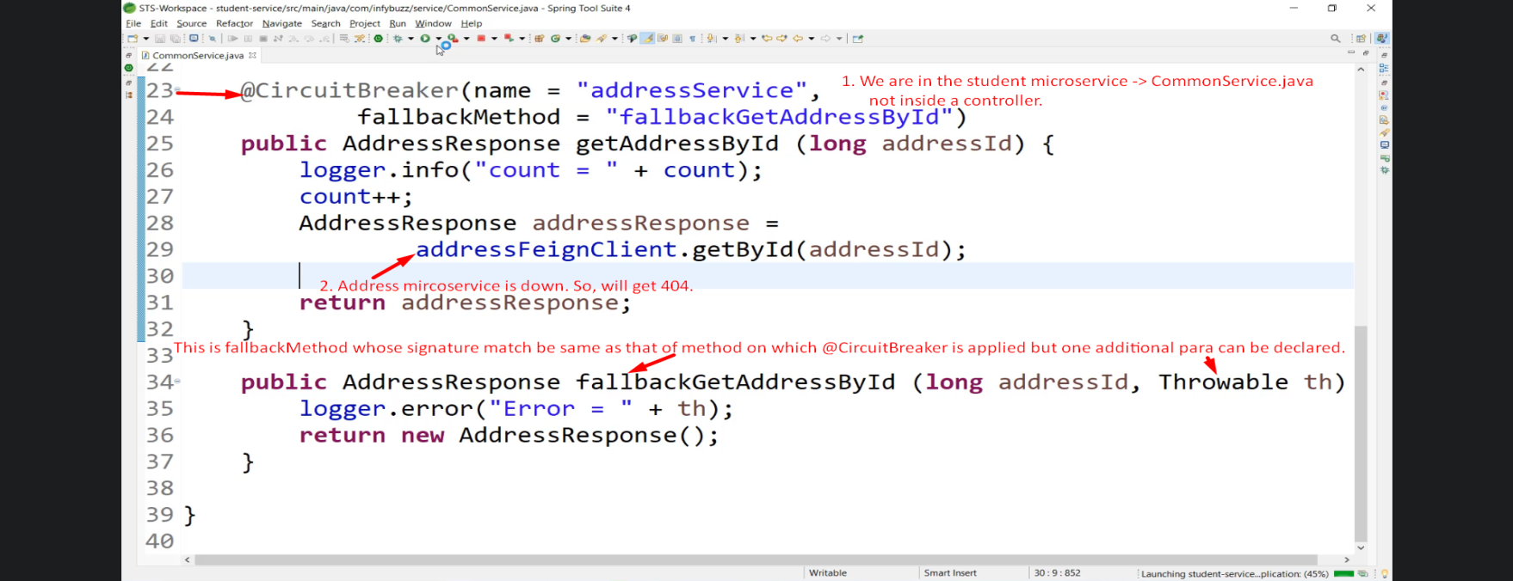
2. 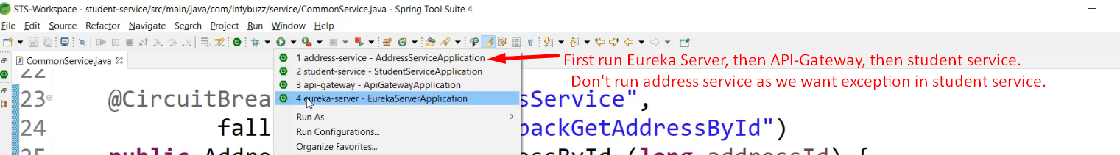
3. 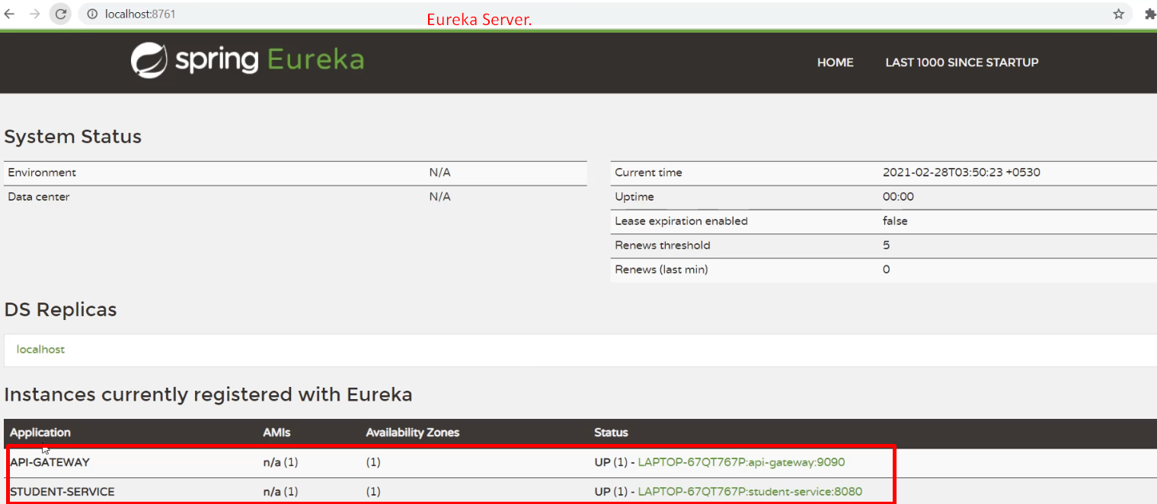
4. 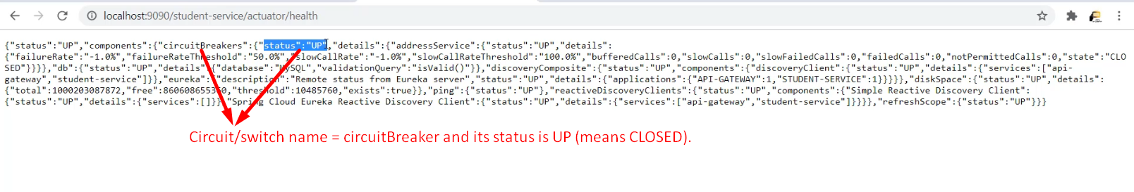
5. 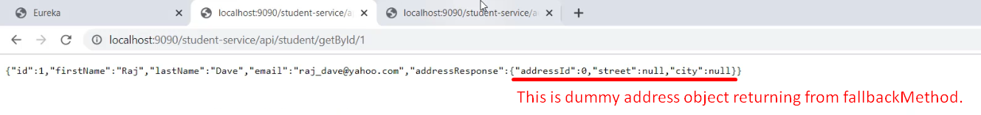 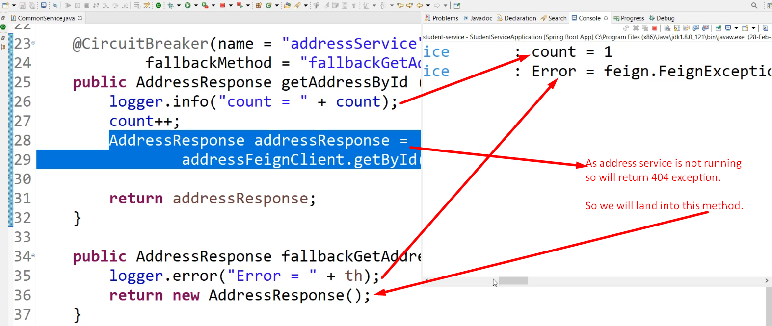
6. 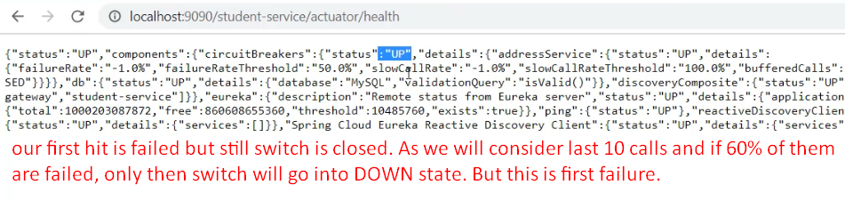
7. 
8. 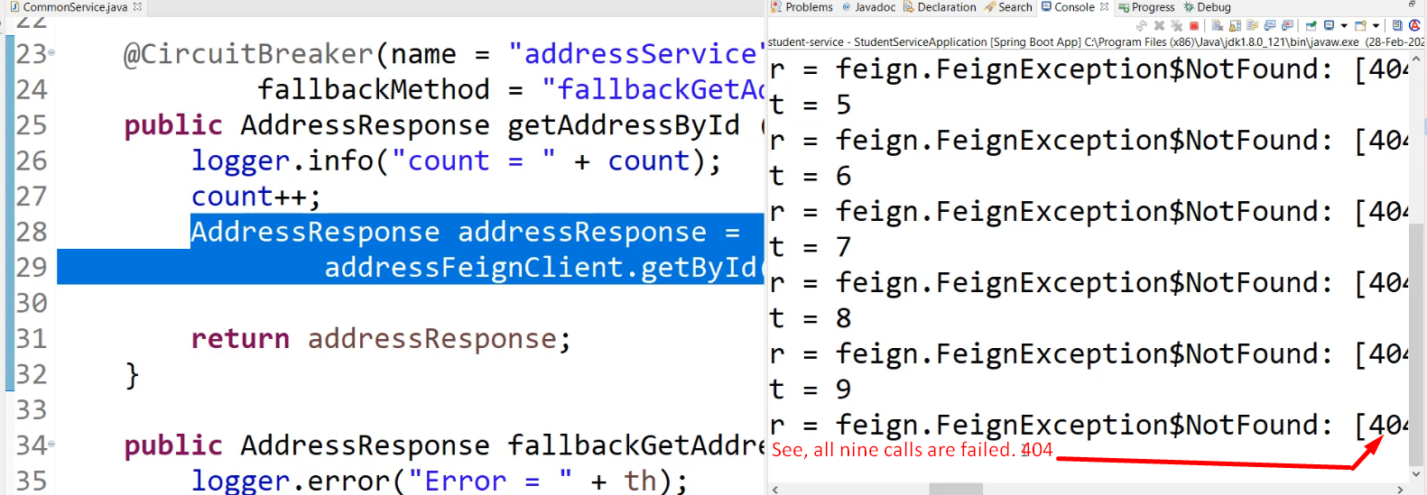
9. 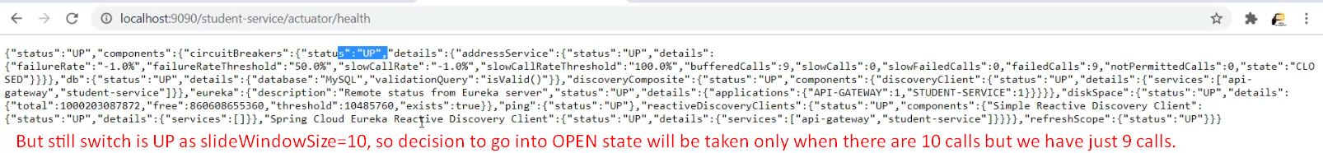
10. 
11. 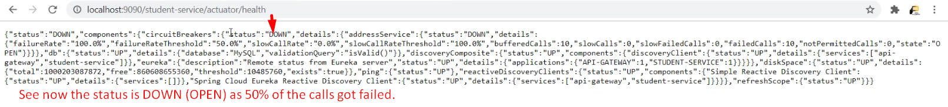
12. 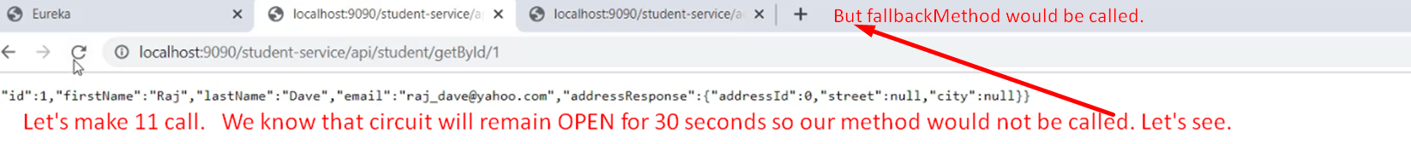
13. 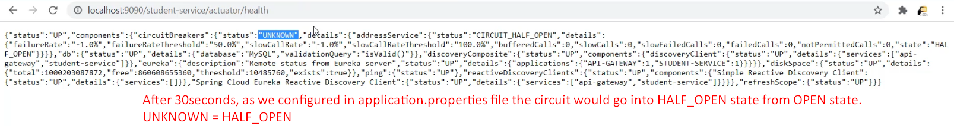
14. 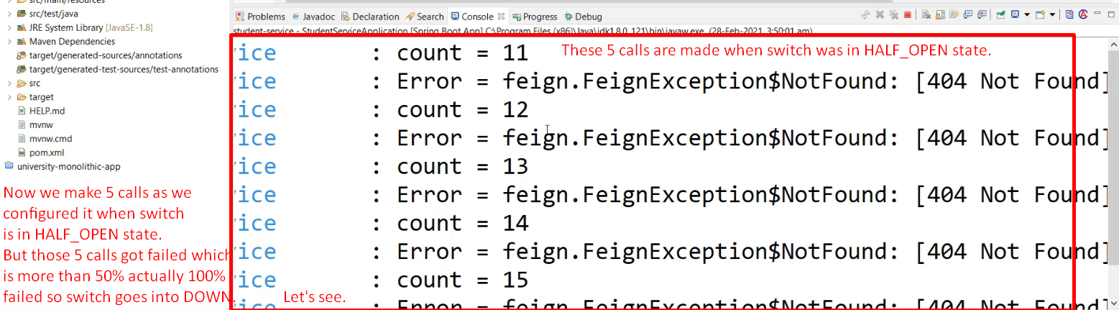
15. 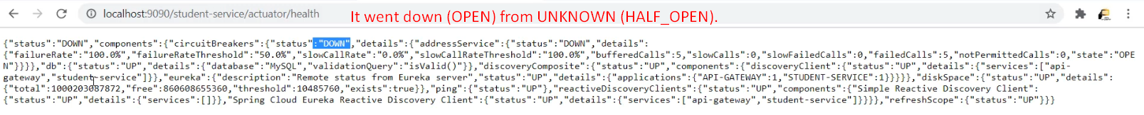
16. 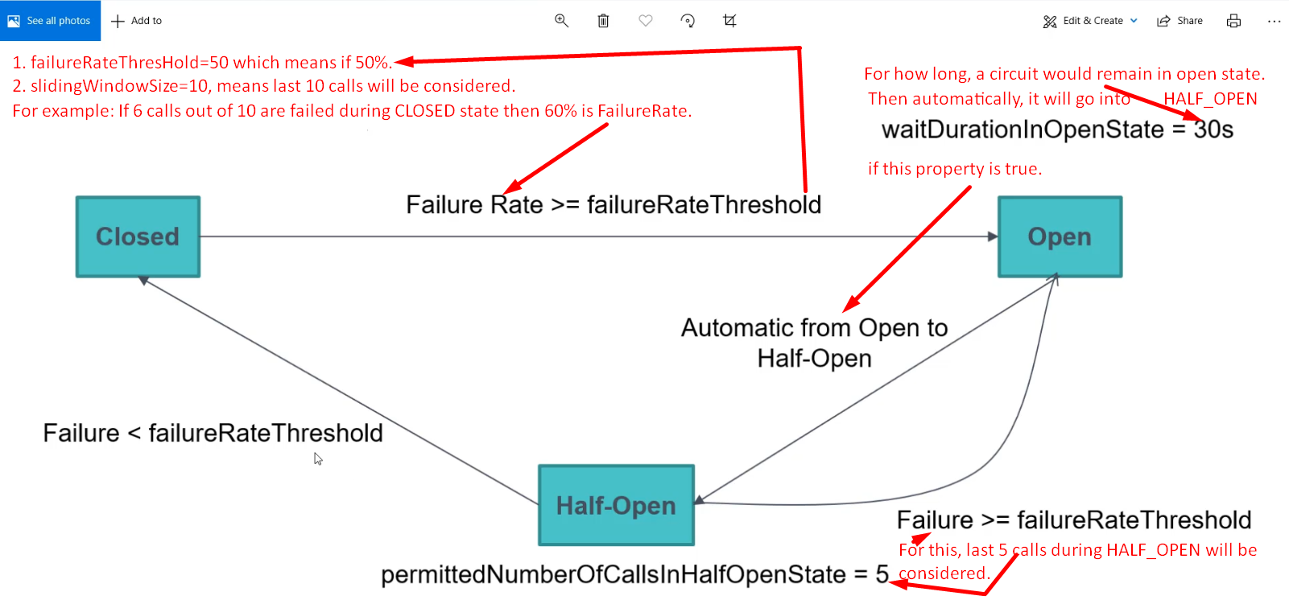
17. There are some scenarios where we should not use circuitbreaker.